**Introduction**

Adding a new dog to your family can be a challenging yet enjoyable process, and this project is designed to take some stress away and make sure you’re prepared to know where you can go for all your dog’s needs. Dogs have always been human’s best friends, and since the pandemic, the number of dogs who are in foster homes or have been adopted has increased. In addition to a place to live, dogs require exercise, water, health care and food. Pet services, such as groomers and pet food stores, or parks for exercising dogs are locations dog owners may seek as amenities for or activities to do with their dogs. No matter the lifestyle dogs have, there are places of which their owners’ need to be mindful to best take care of their dogs. There are some owners who pamper their companion and have matching outfits or hair styles, and would therefore be more likely to frequent groomers. Other dog owners exercise outdoors with their dogs and would look for parks or lakes that allow dogs. This project will explore Boston, MA to find dog related venues. Whether an owner is getting a new dog, moving, or simply looking for alternative dog venues, it is helpful to know locations they can bring their dogs to get the care they need.

**Data**

In order to obtain the location data of the dog venues, the following categories will be explored: Dog Runs, Outdoors, Parks, Pet Services, Pet Stores, Playgrounds, Spas, Lake, Beach, Veterinarian and Medical Centers. Using the geopy and folium applications in python, location data and places of interest will be extracted from Foursquare API data. From there, the aforementioned places of interest will be displayed on a map. Using the map, dog owners can decide where to take their dogs for exercise, to a groomer, or where to purchase pet supplies. The more places of interest for dogs, the more a city will be considered dog friendly. The various categories of dog venues will be shown in different colors on a map so as to make it easier for owners to focus on which venue is of interest.

**Methodology**

Data was extracted from Foursquare API with search queries from eleven categories: Dog Runs, Outdoors & Recreation, Parks, Pet Services, Pet Stores, Playgrounds, Spas, Lake, Beach, Veterinarian and Medical Centers. The number of venues of each category was limited to the top 50 so as not to overwhelm the owners with choices. Of course, future research could be done to explore more of the venue(s) of interest.

Extracting the ‘Park’ venues proved challenging, as the code was extracting data from every row that contained the word ‘Park,’ which included street names or metro stations. Because metro stations or street names should not be considered dog venues, I used the category id for ‘Park’ to complete the search correctly.

When extracting ‘Pet’ venues, I at first only included only the search for ‘Pet’ but as I looked through the results, I came across entries for pets that had various category ids, such as ‘Spa’ and ‘Veterinarian.’ That cemented my decision to not search for the category id, so the data for the dog venues of other categories could remain in the data.

Next, I extracted data including ‘Dog’ in the search query. That search provided categories related to and not related to dogs, such as ‘Dog Run’ and ‘Restaurants.’ I decided these results could easily be cleaned to remove rows that were not applicable.

The next search was for ‘Outdoors.’ A variety of venues resulted, ranging from ‘Baseball Field’ to ‘Park.’ Since there are multiple outdoor activities to do with dogs, I did not specify the category id and decided to go line by line and choose which venues I thought best to keep and which were not applicable to dog owners.

The final search was for ‘Playground.’ Dog parks are often near playgrounds, and if a family with a dog or dogs is looking for a family friendly activity, this is a popular choice.

Once all the data was collected, I merged the dataframes for each category together and created a new dataframe. From there, I extracted unnecessary rows or duplicates. Since I noticed some venues repeated, especially between searches for ‘Park’ and ‘Playground,’ I excluded the redundancies so as to not provide the same location twice. Since I was working with a small data set of only 233 rows, I was able to go through each row and decide if it were related to a dog venue. The rows that were not related were removed. After the cleaning was complete, 179 venues remained.

Once the compiled data was cleaned, I used the folium application to create maps. The first map created depicted all dog venues throughout Boston. If one of the location makers were clicked, a label popped up with the category name. The second map was a more specific map, including color coded venue markers, making it easier for dog owners to differentiate one venue category from another.

**Results**

Here is a sample from the final compiled table:

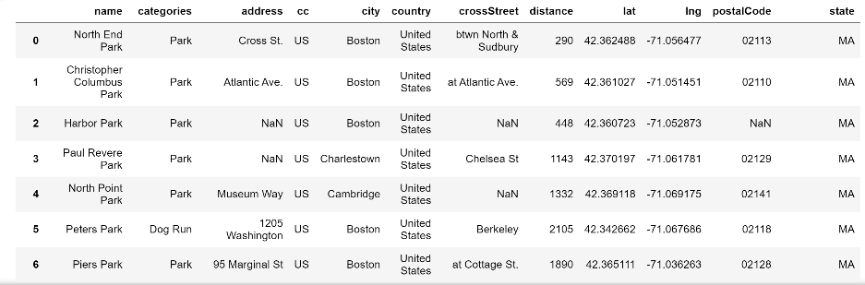

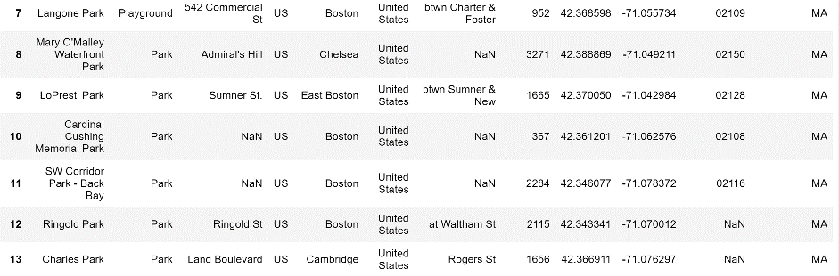

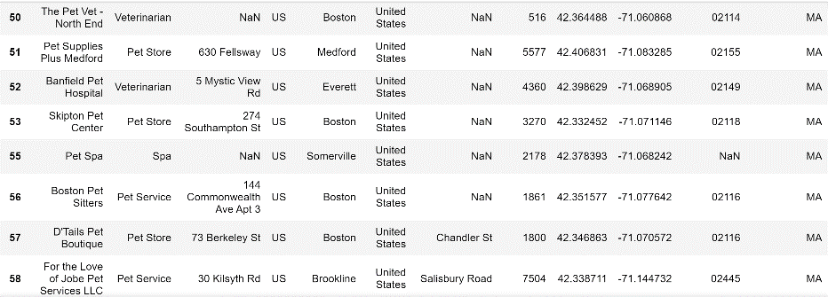

Here is the corresponding location map:

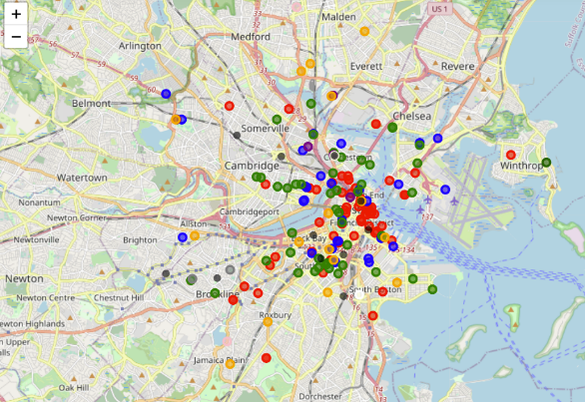

Orange marker = Pet Store

Red marker = Park

Blue marker = Dog Run

Green marker = Playground

Purple marker = Veterinarian

Gray marker = Great Outdoors

Dark purple marker = Pet Services

Beige maker = Spa

White marker = Medical Center

Pink marker = Lake

Dark green = Beach

As shown above, most of the venues are in Boston proper rather than the outlying cities. This is likely because the original coordinates were set for Boston. It is also expected for there to be the most number and variety of venues in Boston because Boston is a city, and most cities are equipped with multiple venues, including those related to dogs. It is not a surprise to see that the ‘Outdoors’ category only has a few venues, since most of the outdoor locations are parks or playgrounds, and both are the prominent venues on the map. While there are a few veterinarian offices scattered around Boston, there is only one medical center, which again does not come as a surprise, since dog owners are more likely to go to a veterinarian than a hospital. Based on the map above, the dog owners are able to get a visual representation of where they can bring their dog, whether they want to get food supplies or just go for a walk in a park.

**Discussion**

There were a few unexpected results from the code that both hindered and improved the results. When I ran the code for the ‘Park’ I noted a few non-dog related results. As a result, I read more about extracting data from Foursquare API and learned more about it as well. It is important to not only understand the data, but to understand the code as well. It was through research I learned about using category id and where to find it in the data. Searching the code for ‘Outdoors,’ I purposely didn’t search using a category id because I wanted to see the different activities or business names that were included in the search results. Based on the output, I got a sense of what was related to the project and what I could remove from the dataframe.

For future research and recommendations, I would suggest increasing the number of venues per category instead of the current limit of fifty. Perhaps if there are more venues included, one could narrow down venues to neighborhoods in Boston instead of the top fifty in all of Boston. There may be other categories not explored in this project that might be of interest to some dog owners, such as trails. It is also possible to create various maps based on dog owners’ lifestyles, such as a map for dog owners who enjoy exploring the city and being outdoors.

**Conclusion**

Current and new dog owners alike have necessary places they need to go to in order to provide for their dog. It may be the veterinarian’s office, a groomer, a pet supply store or a park to go for a walk. Depending on where in Boston, MA the owner would like to go, the owner can look at the map of venues and determine the best establishment. If the owner prefers to take the dog to a groomer, to a park for exercise, and then a pet store for treats, the map can help plan the owner’s path to limit the amount of driving or transportation. In a time where the majority of the population depends on technology to search for recommendations for places from restaurants to bowling alleys, searching for venues for dogs should be just as available. This project aims to provide dog owners with as accessible information as possible to lessen stress, and easily allow owners to explore dog venues in Boston without having to go outside.